Contents

Introduction 2

Search by Open Contracting ID 4

Buyer Profile 5

Contracts Register 5

Scottish Government Collaborative Contracts Directory (out with PCS) 6

Feedback 8

# Introduction

**Public Contracts Scotland Open Contracting Information**

All information contained in notices published on PCS is available in open, re-usable formats compliant with the [Open Contracting Data Standard (OCDS),](https://standard.open-contracting.org/latest/en/#:~:text=The%20Open%20Contracting%20Data%20Standard%20%28OCDS%29%20enables%20disclosure,contracting%20data%20by%20a%20wide%20range%20of%20users.)  an internationally recognised standard for the publication of procurement information. The information is published in line with [Open Government Licence](http://www.nationalarchives.gov.uk/doc/open-government-licence/version/3/) which allows users to use and re-use the Information that is available under this licence freely and flexibly, with only a few conditions.

This information is available on the PCS transparency page

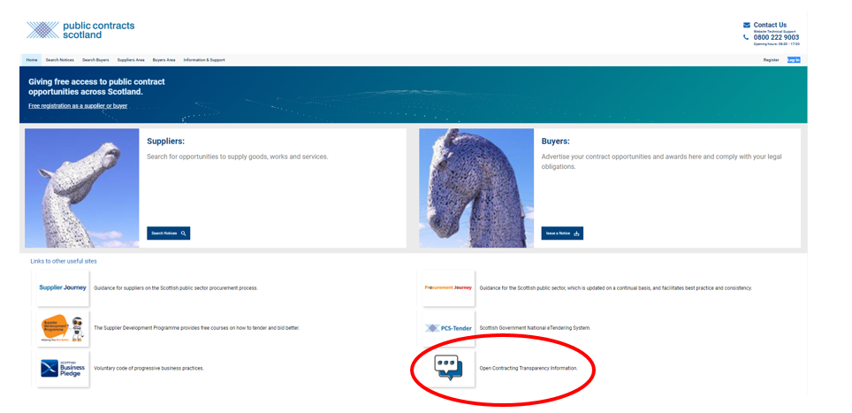

It can be accessed directly from the PCS front page by clicking on the transparency information icon.

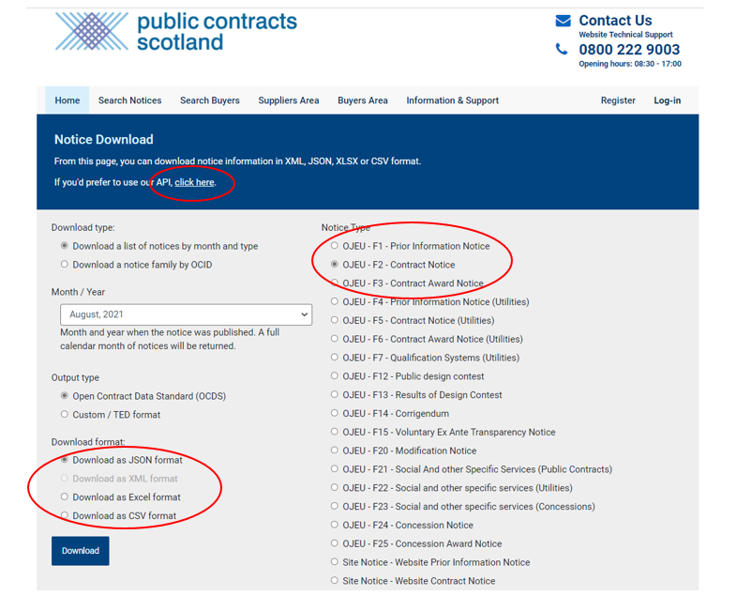

The notice information is available to bulk download by notice type in JSON, XML and Excel. The information can be downloaded by the month the notice was published.

The information is also available as an API by clicking the link at the top of the page.

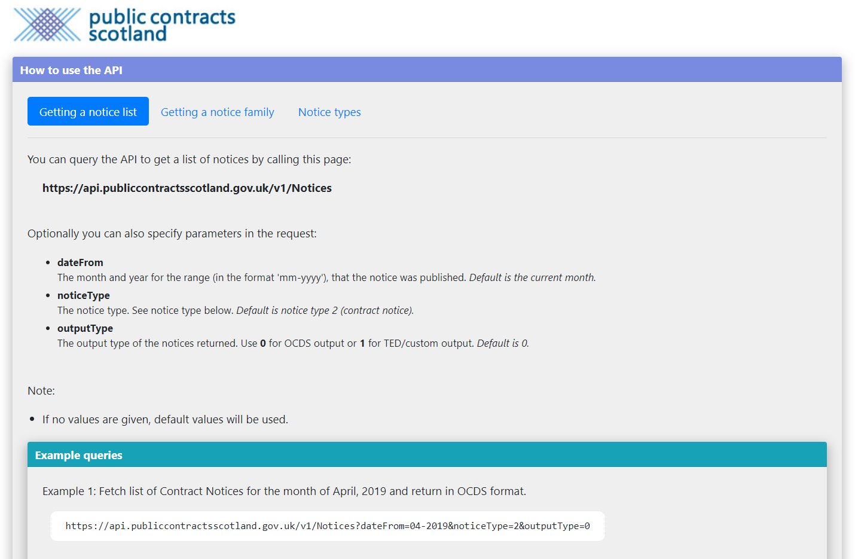

The Application Programme Interface (API) enables a bulk download of all notice information in a machine readable format.

# Search by Open Contracting ID

All notices on PCS have an Open Contracting ID (OCID) allocated to them. This is a globally unique reference number that is applied to a family of notices (For example a PIN, contact notice and contract award will be linked by this ID).

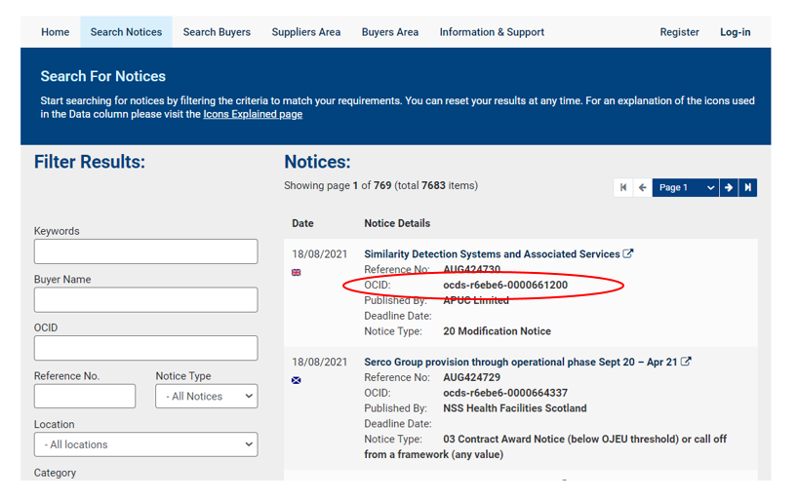

This is publicly visible to users and can be used to search for notices.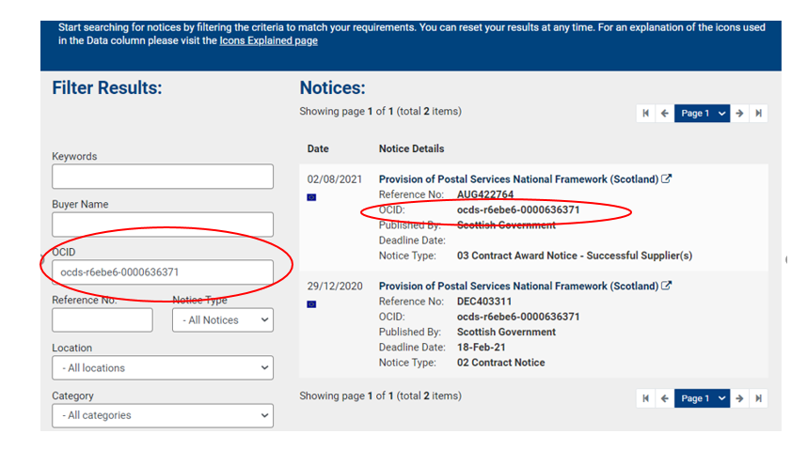

# Buyer Profile

Each organisation on PCS has a buyer profile, which allows users to view information such as contract registers, notices and statistics related to the organisation. This can be found by searching the name of the organisation in the ‘Search Buyers’ area.

Then you can click on each tab to view the related information.

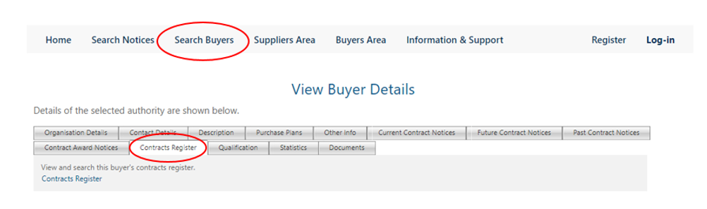

For example, clicking into the statistics tab will allow you to see the organisation’s activity over the last 6 months and in total.

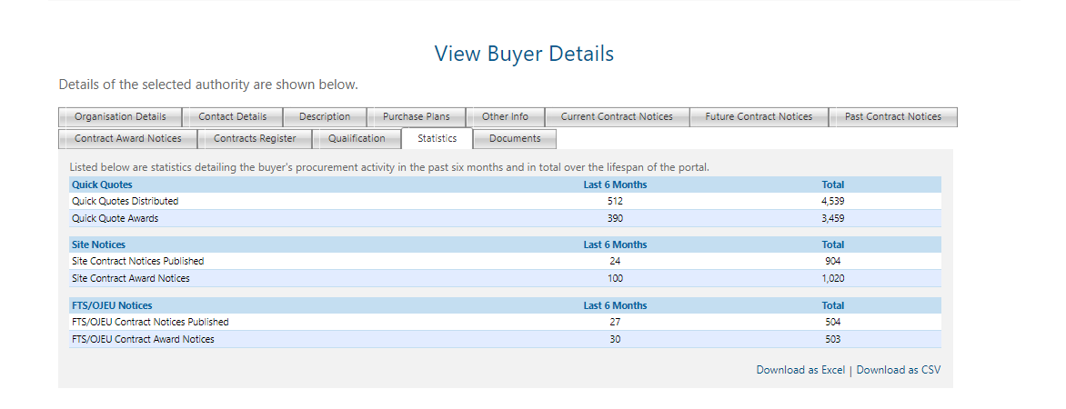

# Contracts Register

Contracting authorities can also choose to publish their contracts register on PCS. If they do so, this will be

visible in the contracts register tab.

.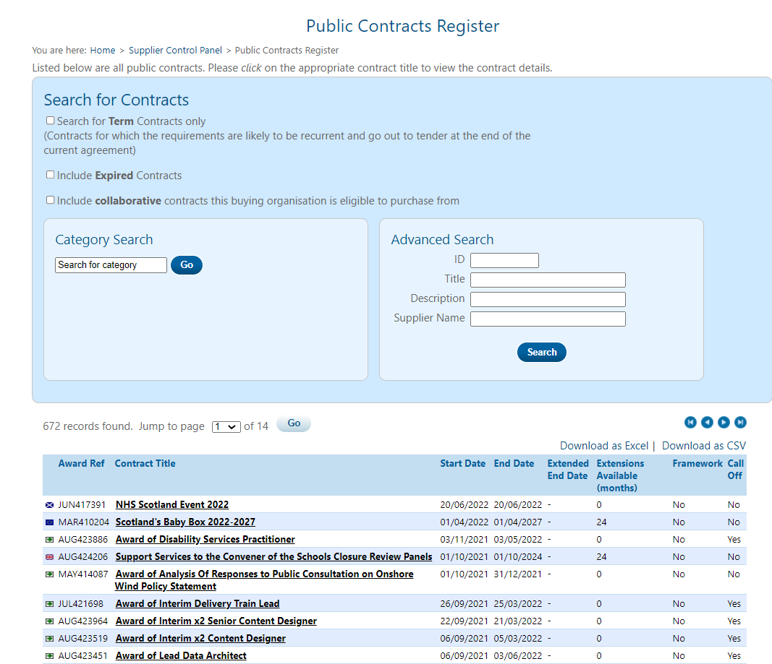

The contracts register details information about the contracts the organisation has put in place. You can also view the notices linked to each contract.

# Scottish Government Collaborative Contracts Directory (out with PCS)

From June 2019, the Scottish Government have published all contract documents related to their large collaborative contracts. The directory can be found on the Scottish Government website at <https://www.gov.scot/publications/frameworks-and-contracts/>.

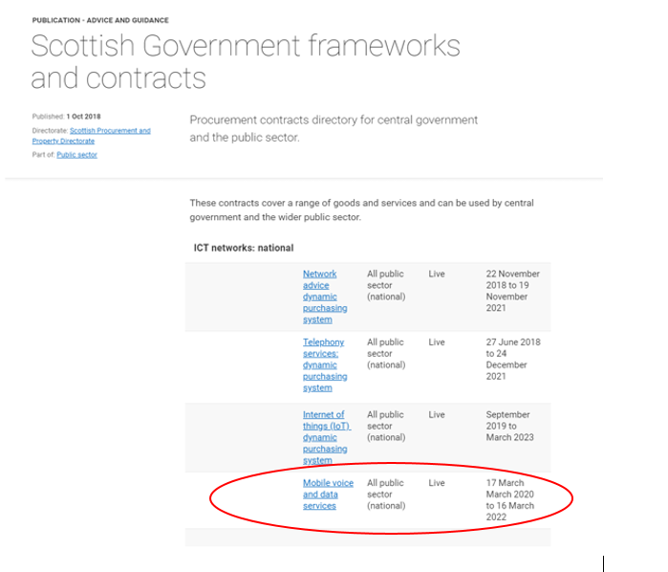

You can click into each contract to see more information and you can find links to the original contract notice on PCS and the contract or framework document if they have been published.

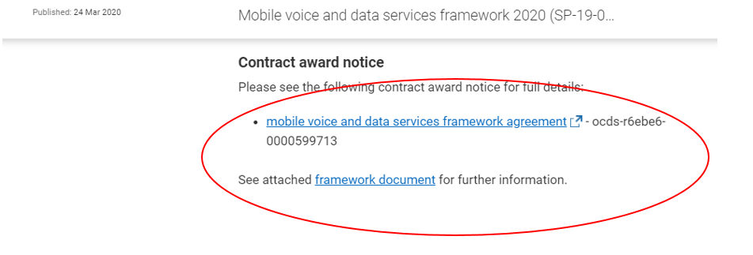

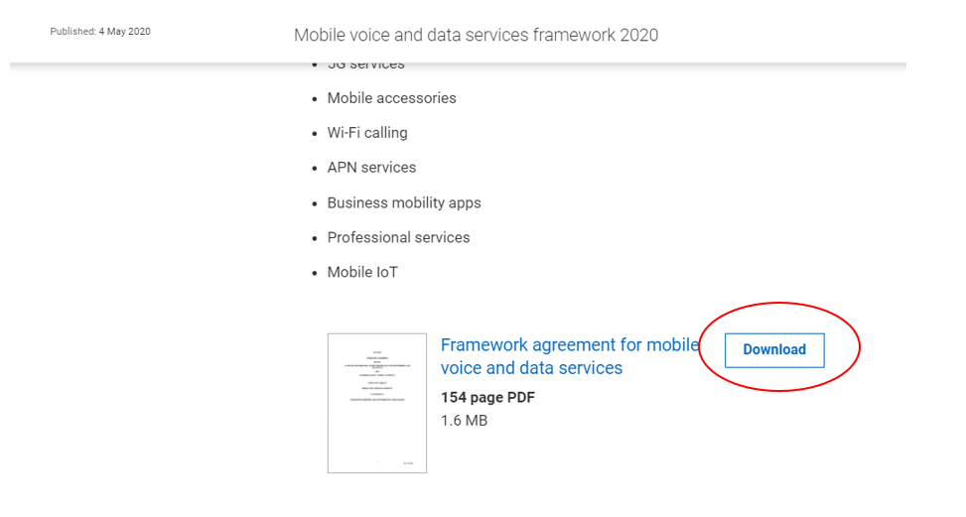

Click on download to view the document in full.

# Feedback

If you have any feedback, please contact opencontacting@gov.scot